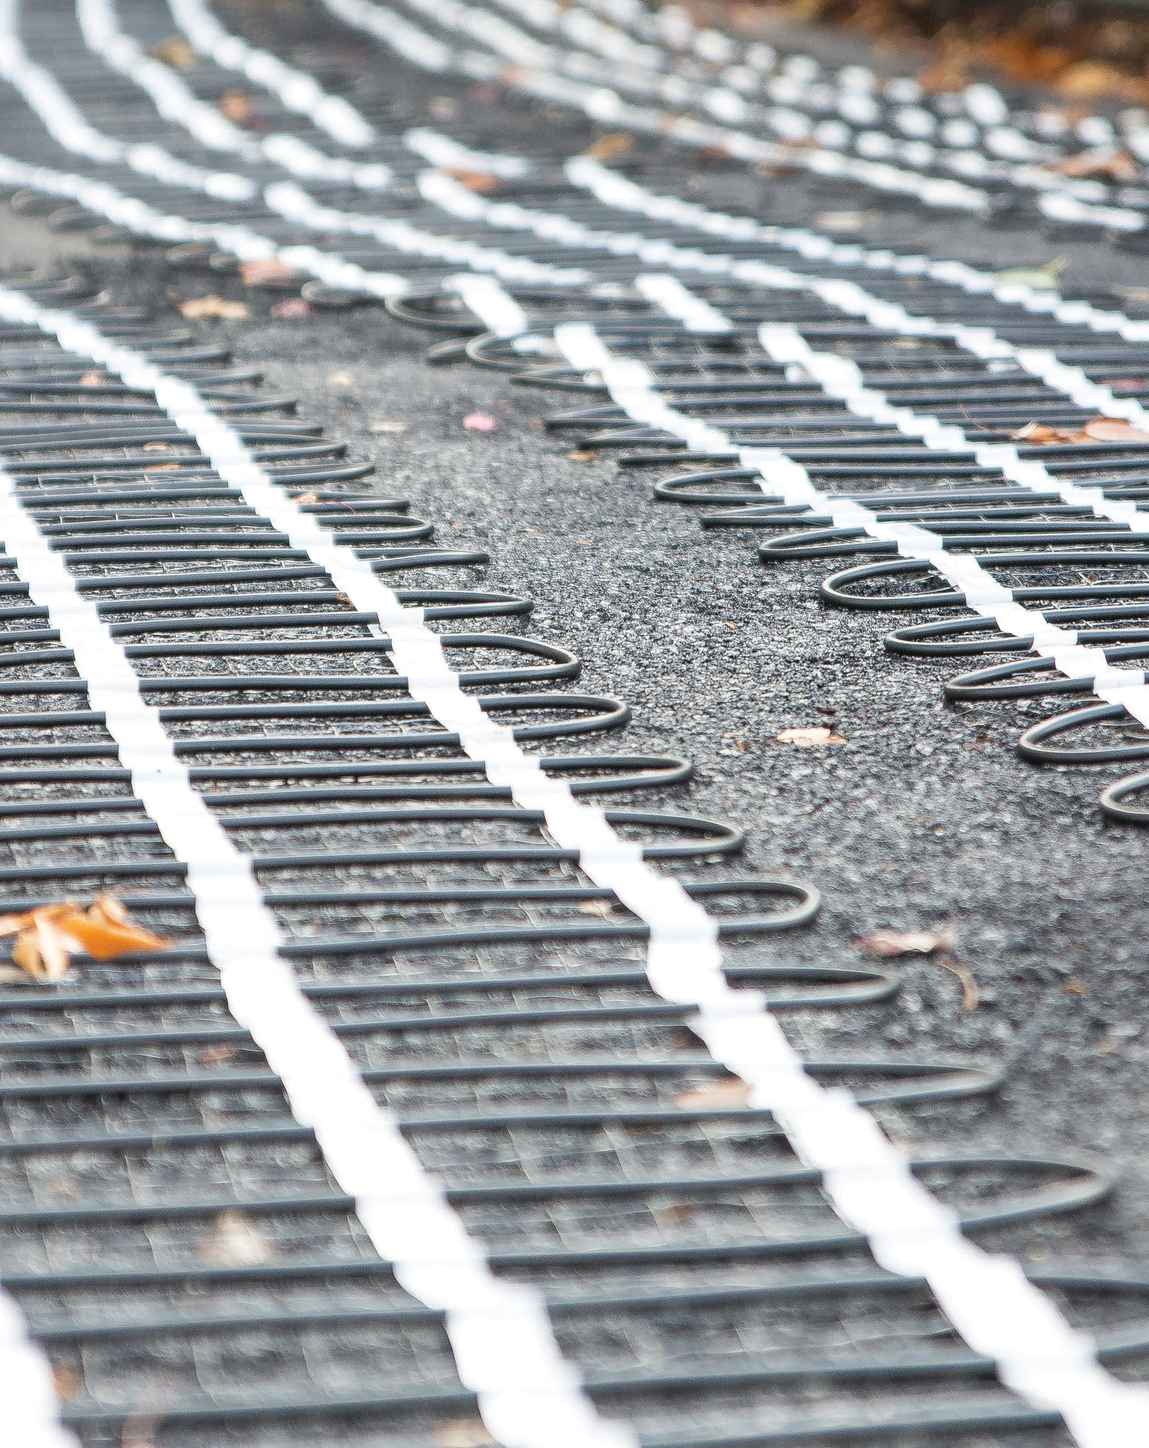 ELECTRIC SNOW MELTING
CABLE & MATS

USE UNDER PAVERS, ASPHALT AND CONCRETE

US +1 (888) 927-6333 / CA 1+ (888) 592-7687
ussales@warmup.com www.warmup.com / www.warmup.ca

1.1 Section Includes

- Electric radiant snow melting mats or cables embedded in outdoor concrete or asphalt slabs, or buried under brick/stone pavers within a sand, stone dust, or mortar bed.

- Controls, sensors, and relay panels.

- Electric radiant snow melting system components, accessories, and associated installation materials.

1.2 Related Sections

- Section 013300 – Submittal Procedures  - Section 014100 – Regulatory Requirements | G.  H. | Section 321216 – Asphalt Paving  Section 321400 – Unit Paving
C. Section 014300 – Quality Assurance | I. | Section 260620.16 – Electrical
D. Section 017000 – Execution and Closeout | J. | Section 260620.23 - Electrical
E. Section 033000 – Cast-in-Place Concrete | K. | Section 262200 – Low Voltage
F. Section 321313 – Concrete Paving | L. | Section 312300 – Excavation/Fill
1.3 References

- National Electrical Code (NEC)
- Canadian Standards Association (CSA)
- Underwriter’s Laboratory (UL)
- American Society of Concrete Contractors (ASCC)
- Warmup Snow Melting System Installation Manual

1.4 Performance Requirements

- Electric snow melting mats/cables must generate 37-58 watts per square foot depending on application and voltage supply. Mat/cable heaters that generate less than 37 w/sq ft, will not be acceptable. Cable jacket must be reinforced for commercial environments and asphalt temperatures.

- Heating wire must be at least ¼” diameter, 2-conductor resistance heating element and withstand up to 474°F asphalt pours.

- All mats/cables shall include 16ft cold leads. This connection is factory joined in a water resistant joint assembly. Cold leads must be tagged with a regulatory label (showing ohms, voltage, amps, length).

1.5 Submittals

- Submit under provisions of Section 013300

- Provide General Contractor, Architect, MEP Engineer, and Owner with all the Manufacturer’s product data sheets, warranty, and installation instructions.

- Provide General Contractor, Architect, MEP Engineer, and Owner with all relevant Shop Drawings, Samples, Mock-Ups, and Electrical Schematics.

1.6 Quality Assurance

- Manufacturer Qualifications & Services:
  - 20 years of experience (minimum) with deicing systems.
  - Heating cable, controls, sensors, relays, and related items shall be provided by one supplier.
  - Supplier must be able to provide outsite field support, 24/7 technical install support, and free design assistance.

- Installer Qualifications:
  - Must have verifiable experience successfully completing projects of similar size, and /or has been trained or certified by a manufacturer’s representative.
  - A licensed electrician shall complete all electrical rough-in, and electrical connections required to complete the system installation.

- Regulatory Requirements and Approvals - Electric Snow Melting Systems
  - Snow melting cables/mats for installation in concrete, asphalt, or under pavers shall be Listed to UL 1673, UL 515, ANSI/IEEE 515.1 and CAN/CSA -C22.2 No. 130-30.

- Pre-Installation Meetings:
  - Coordinate work with other trade representatives (general, electrical, paving, and other trade contractors) to verify areas of responsibility (scope of work).
  - Review project timeline and construction deadlines to ensure project will comply with all manufacturer’s installation instructions and warranty requirements.

1.7 Delivery, Storage and Handling

- Deliver materials in manufacturer’s original, unopened, undamaged containers with identification labels intact.

- Store materials protected from exposure to harmful site conditions, and in an area protected from vandalism and theft.

2.1 Manufacturer
- Warmup Inc., a division of Warmup PLC (UK) US +1 (888) 927-6333 / CA 1+ (888) 592-7687 52 Federal Road, Unit 1F, Danbury, CT 06810 www.warmup.com/www.warmup.ca

- Substitution requests must be approved 15 days prior to bid due date.
Alternative equipment manufacturer must provide all relevant product data sheets, warranty, installation instructions, shop drawings, samples, and electrical schematics. Alternative equipment must meet specified material standards.

2.2 Electric Radiant Snow Melting Mat/Cable

- The Warmup Snowmelting system must consist of Twin Conductor resistance heating cable having Flouropolymer as primary insulation, covered with metal sheathing to provide extra mechanical strength and provide a ground path. A final outer jacket of Zero Halogen Polyolefin is added to provide corrosive protection.

- The Warmup Snow Melting Mat/Cable shall be rated 208-277V, producing 37-58 watts per square foot and be CSA listed. Multiple mat systems must be wired in parallel by the installer. Each mat/cable heater must carry a minimum 10 yr manufacturers warranty.

2.3 Controls, Sensors & Accessories

- AirSense: Outdoor moisture and temperature sensor, supplied with mounting bracket.

- Nameplate: Branded Name Plate for use with Warmup Snow Melt Heater installations (NEC426-13). Dimensions 4” by 6”.

- Alligator: Warmup Digital Multimeter
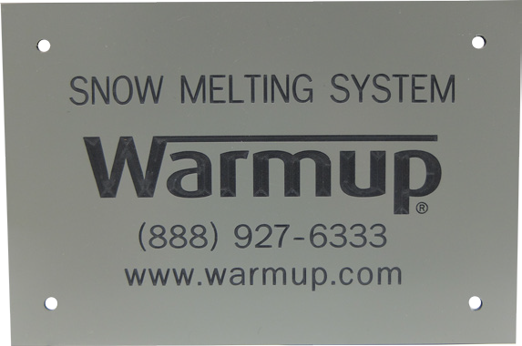

3.1 Manufacturer’s Instructions

A. Comply with manufacturer’s product data, including product technical bulletins, installation instructions and design drawings.

3.2 Examination & Preparation

- Installer shall verify field measurements are as shown on Shop Drawing(s). The installing con tractor is responsible for verifying accurate dimensions are used on drawings.

- Any revisions needed to Shop Drawing(s), or product provided, must be corrected prior to proceeding with the installation.

- Prepare your base, as per the standard guidelines set forth by the American Society of Concrete Contractors. Remove any debris that may damage the heating mat.

- Installer shall verify that the required power is available in proper location, and ready for use.

3.3 Installation

A. Complete installation must conform to appropriate manufacturer’s installation instructions, National Electrical Code, and appropriate local codes.

3.4 Field Quality Control

- Monitor ohms with Warmup Alligator and report readings on warranty card before, during and after the installation.

- Test each heating cable for insulation resistance with a 500 VDC Meg-Ohm Meter. Heater cable should have a minimum insulation resistance of 20 megohms. Record these values on the warranty form provided at the end of the Warmup Installation Manual.

- Start-up ( first-time activation ) must wait for the mortar, concrete or asphalt to be fully cured

- During “Start-Up”, voltage and amps should be tested by a licensed electrician

- All testing records should be copied, and provided to the Owner.

