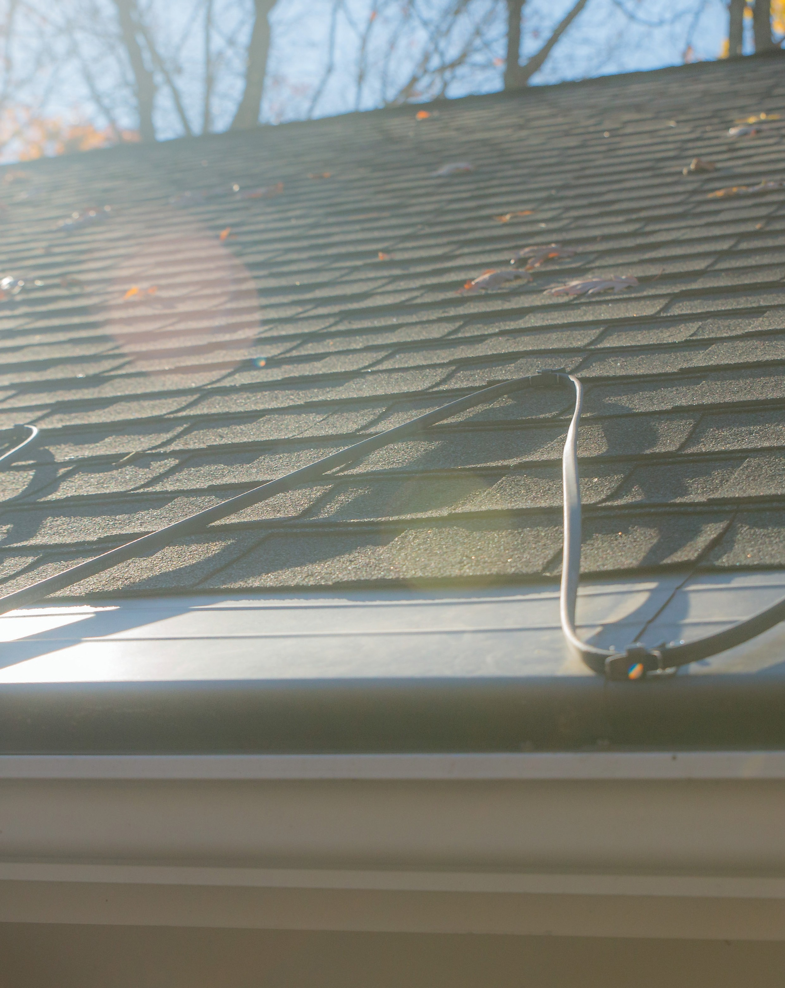 ELECTRIC ROOF, GUTTER & DOWNSPOUT
DEICING CABLE SYSTEM

US +1 (888) 927-6333 / CA 1+ (888) 592-7687
ussales@warmup.com www.warmup.com / www.warmup.ca

1.1 Section Includes

- Electric heating cable for deicing / ice dam prevention, on roofs, in gutters, and in downspouts (roof drains).

- Automatic controls, snow sensors, and relay panels (for load switching).

- Electric roof deicing cable system components, accessories, and install materials.

1.2 Related Sections

- Section 013300 – Submittal Procedures  - Section 014100 – Regulatory Requirements | G.  H. | Section 073100 – Shingles  Section 075000 - Membrane
C. Section 014300 – Quality Assurance | I. | Section 073200 – Roof Tiles
D. Section 017000 – Execution and Closeout | J. | Section 074100 – Roof Panels
E. Section 070150.81 – Roof Replacement | K. | Section 077123 – Gutter Guard
F. Section 070150.91 – Roof Restoration | L. | Section 260620 - Electrical
1.3 References

- National Electrical Code (NEC)
- Canadian Standards Association (CSA)
- Underwriter’s Laboratory (UL)
- Warmup Roof Deicing Installation Manual

1.4 Performance Requirements

- Heating cable must generate 3, 5, 8, 10 & 12 Watts per foot, when dry at 50°F. Plug-in style constant watt heaters will not be acceptable for this application.

- Cable heaters that do not allow for in-field modifications by the installer are not acceptable for this application.

1.5 Submittals

- Submit under provisions of Section 013300.

- Provide General Contractor, Architect, MEP Engineer, and Owner with all the Manufacturer’s product data sheets, warranty, and installation instructions.

- Provide General Contractor, Architect, MEP Engineer, and Owner with all relevant Shop Drawings, Samples, Mock-Ups, and Electrical Schematics.

1.6 Quality Assurance

- Manufacturer Qualifications & Services:
  - 20 years of experience (minimum) with deicing systems.
  - Heating cable, controls, sensors, relays, and related items shall be provided by one supplier.
  - Supplier must be able to provide onsite field assistance, 24/7 technical install support, and free design service.

- Installer Qualifications:
  - Must have verifiable experience successfully completing projects of similar size, and /or has been trained or certified by a manufacturer’s representative.
  - A licensed electrician shall complete all electrical rough-in, and electrical connections required to complete the system installation.

- Pre-Installation Meetings:
  - Coordinate work with other trade representatives (general, electrical, roofing, and other trade contractors) to verify areas of responsibility (scope of work).
  - Review project timeline and construction deadlines to ensure project will comply with all manufacturer’s installation instructions and warranty requirements.

1.7 Delivery, Storage and Handling

- Deliver materials in manufacturer’s original, unopened, undamaged containers with identification labels intact.

- Store materials protected from exposure to harmful site conditions, and in an area protected from vandalism and theft.

2.1 Manufacturer

- Warmup Inc., a division of Warmup PLC (UK) US +1 (888) 927-6333 / CA 1+ (888) 592-7687 52 Federal Road, Unit 1F, Danbury, CT 06810 www.warmup.com/www.warmup.ca

- Substitution requests must be approved 15 days prior to bid due date.
Alternative equipment manufacturer must provide all relevant product data sheets, warranty, installation instructions, shop drawings, samples, and electrical schematics. Alternative equipment must meet specified material standards.

2.2 Electric Roof Deicing Heating Cable

A. The heating cable shall be 120 VAC or 240 VAC rated (240 VAC cable may be operated safely at 208 VAC, 240 VAC, or 277 VAC). Cable heaters must not be pre-terminated with plugs.
Cables heaters must include a 10 year warranty (minimum).

2.3 Controller, Sensor & Accessories
- Commbox-600: Plug-and-Play outdoor controller with 4 x 50A/3 pole contactors allowing for a total load of 600A with a minimum power supply of 60A. Comes in LED enclosure with GFEP protection, built-in Digital controller and ground temperature sensor.

- AirSense: Outdoor moisture and temperature sensor, supplied with mounting bracket.

- SST-2: Electronic Thermostat with GFEP for Freeze Protection - 30A w/ GFEP

- Speedfit:

SPEEDFIT-BOX: Power connection junction box (6x6x3) with Pipe-Mounting Bracket for Self- Reg connections.
SPEEDFIT-SPLICE: In-line splicing box for fast and weathertight connections in the field. SPEEDFIT-TEE: 3-Way T-splice box for fast and weathertight connections in the field.

3.1 Manufacturer’s Instructions

A. Comply with manufacturer’s product data, including product technical bulletins, installation instructions and design drawings.

3.2 Examination & Preparation

- Installer shall verify field measurements are as shown on Shop Drawing(s). It is the installing contractor’s responsibility to verify accurate dimensions prior to installation.

- Any revisions needed to Shop Drawing(s), or product provided, must be corrected prior to proceeding with the installation.

- Installer shall verify that the required power is available in proper location, and ready for use.

3.3 Installation

A. Complete installation must conform to appropriate manufacturer’s installation instructions, National Electrical Code, and appropriate local codes.

3.4 Field Quality Control

- Test each heating cable for insulation resistance with a 500 VDC Meg-Ohm Meter. Heater cable should have a minimum insulation resistance of 20 megohms. Record these values on the warranty form provided at the end of the Warmup Installation Manual.

- Start-up (first-time activation) may proceed immediately after the licensed electrician has every component wired up correctly.

- During “Start-Up”, amps of each heater should be tested by a licensed electrician.

- All testing records should be copied, and provided to the Owner.

